



Volume 14 Issue 5 Lindley 6th Grade Academy January 2015

Falcons News Crew – we are accepting applications for positions on a second news crew. You can find the applications in the Media Center with Students Information.

Media Crew – We will have a Media Crew meeting this month. We are still accepting applications. You can find the application on the Media Center website, http://lsgamediacenter.weebly.com/media-crew.html





Our new E-books are here and ready for checkout!! Just log on to the Cobb Digital Library using your lunch number and the password read to check out all of our new additions to the Media Center!! Mackin Educational Resources - E-Resources

Teachers

Please remember to forward me any suggestions for purchases that would assist you with teaching the core curriculum



Literary Birthdays:

JRR Tolkein – Jan. 3

Jacob Grimm – Jan. 4

Phyliss Reynolds Naylor – Jan. 4

Walter R Brooks – Jan. 9

Jack London – Jan. 12

A.A.Milne – Jan. 18

Lewis Carroll – Jan. 27



Authors for the month:
Phyliss Reynolds Naylor - (born January 4, 1933) is an American writer best known for children's and young-adult fiction. Naylor is best known for her children's-novel trilogy Shiloh (a 1992 Newbery Medal winner) and for her "Alice" book series, one of the most frequently challenged books of the last decade.
Carl Hiassen - born March 12, 1953) is an American journalist, columnist, and novelist.

http://lsgamediacenter.weebly.com/media-crew.html

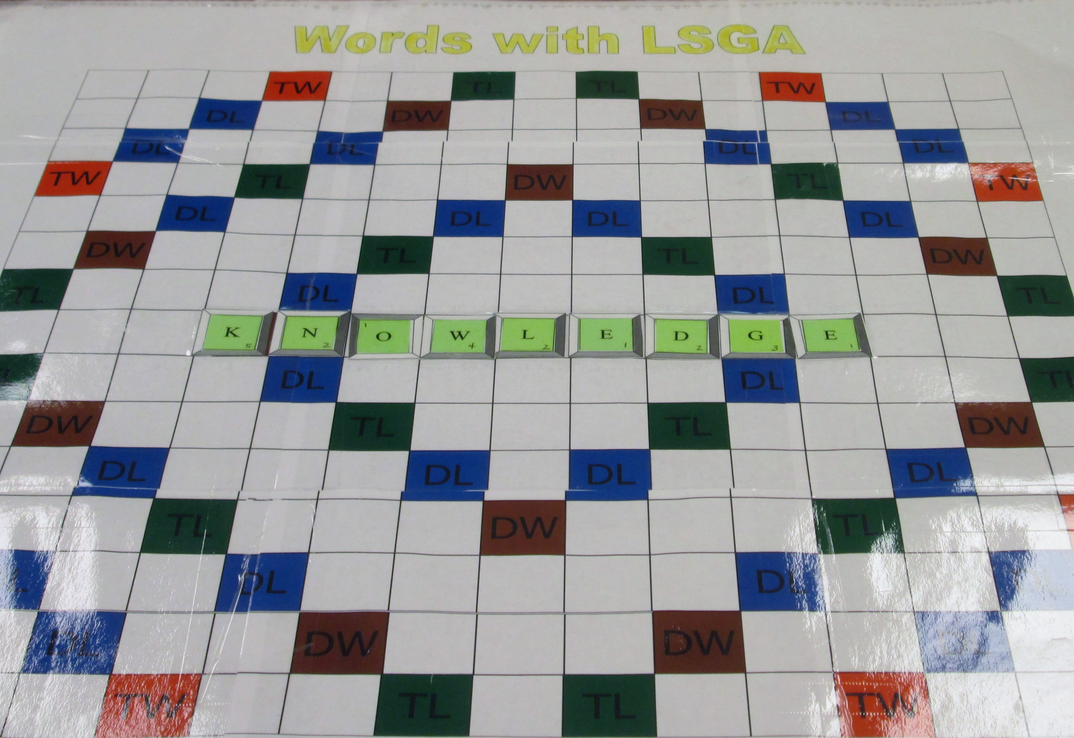 Words with LSGA

Don’t forget to check the board and see if you can assist your team in wing the game.

Dr. Martin Luther King, Jr.
http://www.biography.com/people/martin-luther-king-jr-9365086

Martin Luther King Jr. Online - Speeches, Pictures, Quotes, Biography & Videos for Teachers, Students and Fans

