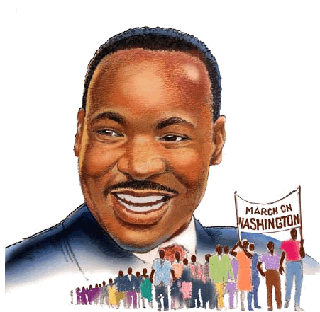

Volume 14 Issue 6 Lindley 6th Grade Academy February 2015

Check out these websites!
African American Artists
African American Inventors
Harlem Renaissance

http://www.history.com/topics/black-history-month
http://www.timeforkids.com/minisite/black-history-month
http://www.biography.com/people/groups/black-history

Literary Birthdays:
Langston Hughes February 1
Meg Cabot February 1
Jerry Spinelli February 1

James Joyce February 2
Sidney Lanier February 3

Charles Dickens February 7

Kate Chopin, February 8

Alice Walker February 8
E.L.Konigsburg February 10
Jacqueline Woodson February 12

Toni Morrison February 18

Carson McCullers February 19
W.E.B. DuBois February 23

John Steinbeck February 27
Henry Longfellow February 27



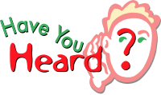
About the different contest going on in the Media Center:

- Black History
- Blind Date with a Book

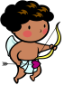One legend contends that Valentine was a priest who served during the third century in Rome. When Emperor Claudius II decided that single men made better soldiers than those with wives and families, he outlawed marriage for young men — his crop of potential soldiers. Valentine, realizing the injustice of the decree, defied Claudius and continued to perform marriages for young lovers in secret. When Valentine's actions were discovered, Claudius ordered that he be put to death.


Valentine’s Day





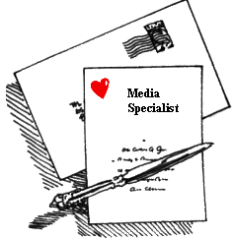


Come see our new
titles!
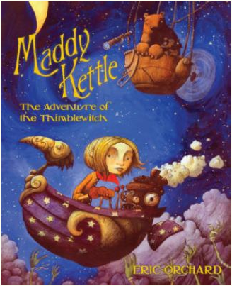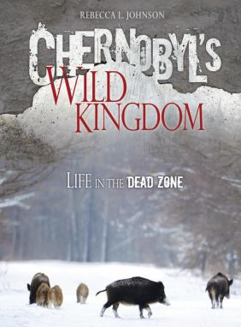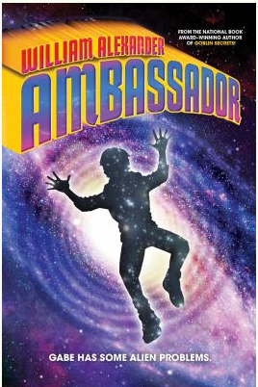

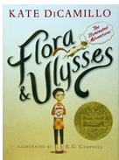
Flora & Ulysses: The Illuminated Adventures, written by Kate DiCamillo and published by Candlewick Press
Comic book fan and natural-born cynic Flora Belle Buckman and Ulysses, a flying, superhero, poetry-writing squirrel, join forces to overcome Ulysses’ arch-nemesis, Flora’s mother and encounter a quirky cast of characters. Through poignant, laugh-out-loud episodes, this homage to comic books is a testament to the power of love.
“Our dedicated committee of 15 considered hundreds and hundreds of titles in our quest for the best books for children, and I am delighted with our selections,” said Newbery Medal Committee Chair Elizabeth C. Orsburn.

The 2014 Newbery Award

