



Volume 14 Issue 4 Lindley 6th Grade Academy December 2014

Spotlight On:
Words with LSGA

Do you play Words with Friends? How about Scrabble? Words with LSGA will begin in December! Teams will compete against each other for an ice cream party!! The game moves counter-clockwise with any student able to form a word (as long as their team is up!) Words need to be checked by Ms. Parker who will keep score! See the video for more information and detailed instructions and Good Luck!!

  - 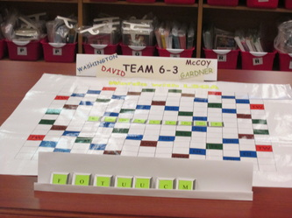

Teachers

Please remember to forward me any suggestions for purchases that would assist you with teaching the core curriculum

Literary Birthdays:

David Macauley – Dec. 2

Munro Leaf – Dec. 4

Joel Chandler Harris- Dec. 9

Jerry Pinkney – Dec. 22

Avi – Dec. 23

Jean van Leeuwen – Dec. 26

Cynthis DeFelice – Dec. 28

Richard Atwater – Dec. 29

Rudyard Kipling – Dec. 30





Keep working for those SOAR cards and doing the right thing even when someone is not watching. SOAR to be recognized as the
FALCON of the month!

Author of the month:

Avi- born in 1937, Edward Irving Wortis (Avi) has written over 70 books in numerous genres. His focus has been on children and young adult literature and has won the Newbery Award (and runner-up twice).
http://www.avi-writer.com/

Best Wishes to You and 
Yours for a Safe and Happy Holiday Season!!

Holiday Resources

http://teacher.scholastic.com/activities/holidays/

http://www.educationworld.com/a_lesson/lesson213.shtml

